**A)Exercise 1:**

**Problem Description**:

* A **company database** needs to store information about **employees** (identified by ssn, with salary and phone as attributes), **departments** (identified by dno, with dname and budget as attributes), and **children of employees** (with name and age as attributes).
* Employees work in departments; each department is managed by an employee; a child must be identified uniquely by name when the parent (who is an employee; assume that only one parent works for the company) is known. We are not interested in information about a child once the parent leaves the company.

**Questions to answer**:

1. Draw an ER diagram that captures this information.
2. Convert from ER diagram to relational schema.

A1.

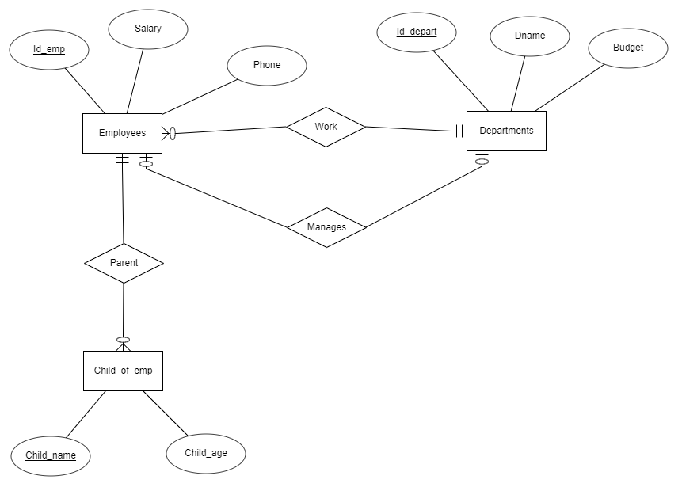

A2.

**Employees**

|  |  |  |  |
| --- | --- | --- | --- |
| Id_emp | Salary | Phone | Id_depart |

**Manages_depart**

|  |  |
| --- | --- |
| Id_depart | Id_emp |

**Departments**

|  |  |  |
| --- | --- | --- |
| Id_depart | Dname | Budget |

**Child_of_emp**

|  |  |  |
| --- | --- | --- |
| Child_name | Child_age | Id_emp |

=====================================================================================

**B) Exercise2:**

**Problem Description**:

Consider the following relations for a database that keeps track of student enrollment in courses and the books adopted for each course (Primary Key is mark post-fix with #):

STUDENT (SSN#, Name, Major, Bdate)

COURSE (Course#, Cname, Dept)

ENROLL (SSN#, Course#, Quarter, Grade)

BOOK_ADOPTION (Course#, Quarter, Book_ISBN#)

BOOK (Book_ISBN#, Book_Title, Publisher, Author)

**Questions to answer**:

Draw a relational schema diagram specifying the foreign keys for this schema.

------------------------------------------------------------------------------------------------------------------------------------------

**STUDENT**

|  |  |  |  |
| --- | --- | --- | --- |
| SSN | Name | Major | Bdate |

**COURSE**

|  |  |  |
| --- | --- | --- |
| Course | Cname | Dept |

**ENROLL**

|  |  |  |  |
| --- | --- | --- | --- |
| SSN | Course | Quarter | Grade |

**BOOK_ADOPTION**

|  |  |  |
| --- | --- | --- |
| Course | Quarter | Book_ISBN |

**BOOK**

|  |  |  |  |
| --- | --- | --- | --- |
| Book_ISBN | Book_Title | Publisher | Author |